Base Design and Innovation (BDI) journal template
Article title (maximum 10 words) [BDI Article title – Título del artículo]
Type or paste your abstract here (maximum 200 words). The abstract should be written with 1.5 line spacing, in Times New Roman font size 12. In a single paragraph, provide a summary of the study that includes the problem, the research question, the participants, the key elements of the methodology, the results, the conclusions, and their implications or applications. References should not be included in the abstract. After the abstract, include up to five keywords separated by commas. Use lowercase letters except for proper nouns. Do not use a period after the last word. [BDI Abstract – Resumen]
Keywords: first word, second word, third word [BDI Keywords – Palabras clave]

Format, style, and heading levels / Subtitle 1 [BDI Heading 1 – Título 1]
An essential aspect of the work of the Base Diseño e Innovación journal is to ensure high technical quality in the articles published. The manuscript file must be as complete as possible. This means that figures, tables, possible endnotes, and the list of references must be included and correctly formatted. Therefore, authors are invited to follow this template rigorously. The first paragraph after a heading should not be indented. [BDI First paragraph – Primer párrafo]

Quotation styles / Subtitle 2 [BDI Heading 2 – Título 2]
There are different styles of quotation marks depending on their shape: curved (“ ”), straight (" "), and angular (« »). All of them can be used in single (‘ ’) or double (“ ”) variants. In your manuscript for Base journal, only use curved quotation marks. For quotations of less than 40 words, article titles, and to emphasize words, use double curved quotation marks (“ ”). For quotations within a quotation in double quotation marks, use single curved quotation marks (Table 1). [BDI First paragraph – Primer párrafo]

Table 1. Quotation mark style used by Base journal [BDI Table Title – Título de tabla]
Style / Name | Symbols | Example | Usage [BDI Table – Tabla]
Double Curved English | “ ” | “Quoted text” | Direct quotes of less than 40 words
Single quotation marks | ‘ ’ | ‘Quoted text’ | Quote within a quote in quotation marks
Straight quotation marks | " " | "Quoted text" | Do not use
Curly or Spanish quotation marks | " " | "Quoted text" | Do not use
Simple straight lines | ' ' | 'Quoted text' | Do not use

Use of italics and quotation marks [BDI Heading 2 – Título 2]
Typographical styles (bold, regular, italics) and quotation marks are used to differentiate words or phrases from the rest of the text. Italics are used to highlight terms that require emphasis or formal differentiation, while quotation marks are used to delimit textual expressions or indicate discursive units that should be distinguished from the main body of the manuscript. Both resources should be used sparingly, consistently, and only when their function contributes to the clarity and precision of the text (Table 2).

Table 2. Use of italics and quotation marks according to APA style, 7th edition. [BDI Table Title – Título de tabla]
Case | Used in | Example(s) | Editorial notes/comments
Titles of complete works (books, films, reports, magazines, etc.) | Italics | Design and Visual Education / El Mercurio | These are written in italics in the text and in the list of references. They are considered independent works.
Titles of parts of a work (chapters, articles, entries, episodes, etc.) | Quotation marks | "Visual management in the classroom" | Quotation marks are used in the text, but in the list of references they are written without quotation marks or italics.
Words or phrases mentioned as such (when referring to the word, not using it) | Quotation marks | The term "design" has multiple meanings. | APA 7th clarifies that quotation marks, not italics, should be used to refer to words or letters as linguistic units.
First mention of a technical or key term defined by the author | Italics | The concept of bioliteracy is essential to this study. | Only the first time the term is used. After that, it is written in regular type.
Non-naturalized foreign words | Italics | The Japanese concept ikigai has no direct translation. | If the word has already been adopted into Spanish or English (such as déjà vu, café), it is not italicized.
Emphasis or specific contrast | Italics | This method is effective, not experimental. | Use sparingly. Do not use quotation marks for emphasis.
Short quotations (less than 40 words) | Quotation marks | According to Schön (1983), "design is a reflective conversation with the situation." | Double quotation marks for short quotations; within them, single quotation marks (‘ ’) for an internal quotation.
Long quotations (40 words or more) | Without quotation marks (indented block) | — | Formatted as a block, with a left indent of 1.27 cm. No quotation marks or italics are used.
Words or phrases used ironically or in a special way | Quotation marks | She called herself an "expert in sustainability." | APA 7th allows this usage, but advises avoiding it unless necessary to mark irony or critical distance.

Style and use of hyphens / Subtitle 2 [BDI Heading 2 – Título 2]
In APA 7th edition style, the correct use of different types of hyphens is essential to ensure clarity and precision in academic writing. Each variant (short, medium, and long hyphen) has specific functions that must be respected to maintain formal consistency in texts (Table 3).

Table 3. Use of hyphens in APA style 7th edition. [BDI Table Title – Título de tabla]
Type of hyphen | Uses | Example
Short dash (-) | • Compound words  • Prefixes  • No spaces before or after | Theory-practice  former student
Long dash or em dash (—) | • Emphatic interruption or parenthetical remark  • Sudden change of topic or emphasis | Design—as an interdisciplinary field—integrates theory and practice.  The result was unexpected—no one had foreseen it.
En dash (–) | • Relationship between concepts  • Numerical ranges (in some publishers) | Teacher–student relationship  Time–space axis  2019–2021, pp. 45–62

Page format / Subtitle 2 [BDI Heading 2 – Título 2]
The file must comply with the following format and style specifications:
- Letter-size paper [BDI Bulleted list – Lista con viñeta]
- 2 cm margin on each side
- New Times Roman font size 12, spacing 2.0
- Numbering in the upper right corner of each page
Please use the [BDI First Paragraph – Primer párrafo] style for the first paragraph of a section and to continue after a list, figure, table, or long quotation. If you are importing your text from a document with custom styles, paste the text as plain text and then format the text using the styles in this template. The sections of your document should be separated by appropriate headings. We recommend not exceeding three levels of subheadings. Do not place additional lines after any of the titles, subtitles, abstracts, keywords, headings, images, captions, and body text. Only after tables is it necessary to include a new line.
Use [BDI New Paragraph – Nuevo párrafo] when you need to start a new paragraph. Think carefully about the presentation of any visual material. It is your responsibility to ensure that you have the rights and permission to use all images in your article.
Short quotations within the text should be marked with double quotation marks, and the reference in the text should include the page number.
Long quotations, containing more than 40 words, should not be enclosed in quotation marks. They are presented in a block, left-aligned and in 12-point font, the same as the text of the paragraphs. At the end of the quotation, the source and page number from which the quotation was taken must be indicated [BDI Displayed quotation – Cita desplegada].
After a long quotation, a new paragraph should begin using [BDI First Paragraph – Primer párrafo].
To compose lists, you can choose between bulleted or numbered lists. The style for each case is indicated below:
- First line of text in a bulleted list [BDI Bulleted list – Lista con viñeta]
- Second line of text in the bulleted list
- Third line of text in the bulleted list
- First line of text in a numbered list [BDI Numbered list – Lista numerada]
- Second line of text in a numbered list
- Third line of text in a numbered list

Heading 2: use this style for level 2 headings [BDI Heading 2 – Título 2]

Title 3: use this style for level 3 headings [BDI Heading 3 – Título 3]
1. This is a note [BDI Footnotes – Nota al pie]

Tables and images [BDI Heading 2 – Título 1]
All tables included in the article must be referenced in the text, numbered consecutively (Table 1, Table 2, etc.) and have a title. Tables must be created in the Word file with editable text (do not use tables as embedded images).

Table 4. Write the title here.
Variable | Variable | Variable | Variable
Concept | Text | Text | Text
Concept | Text | Text | Text

All images included in the article must be referenced in the text and numbered consecutively (Figure 1, Figure 2, etc.). Each image must include a caption with the figure number, title, and a brief description of its content. All images must be sent as separate files in JPG format with a resolution of 300 dpi. The authors are responsible for the images included in the document and must have the necessary authorizations.
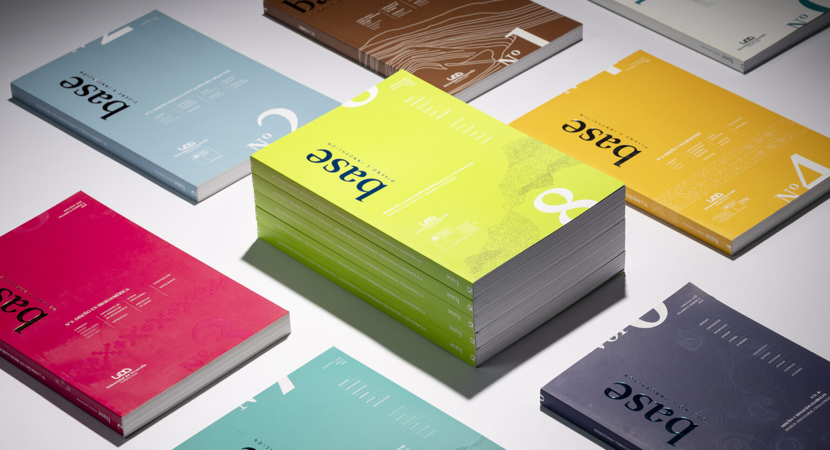
Figure 1. Paste the figure caption here. Remember to include the figure title and a brief explanation of its content. Do not forget to obtain the appropriate permission and include the required acknowledgment from the copyright holder if a figure is obtained from another source. [BDI Figure Caption – Pie de figura]

Resources for improving academic writing
If you have questions about spelling, the correct use of capital letters, or general aspects of academic style, we recommend consulting reliable resources that ensure consistency and accuracy in writing. Base recommends the following websites:
- FundéuRAE (https://www.fundeu.es/) Guidance in Spanish on spelling, grammar, and proper language use.
- Merriam-Webster Dictionary (https://www.merriam-webster.com/) Definitions and examples in English to improve lexical accuracy.
- Merriam-Webster Grammar (https://www.merriam-webster.com/grammar) Rules and practical explanations on English grammar.
- APA Style – Getting Started (https://apastyle.apa.org/beginners) Official guide from the American Psychological Association for beginners, with guidelines on capitalization, writing, and academic style.

References
[Include the list of references here following APA style 7th edition. Below are examples of references in APA format, based on articles published in the Revista Base Diseño e Innovación (BDI) and other external sources. Each reference includes an indication of the type of source (book, journal article, website, book chapter, etc.).]
Avramova, N. (2019, 3 de enero). The secret to a long, happy, healthy life? Think age-positive. CNN. https://edition.cnn.com/2019/01/03/health/respect-toward-elderly-leads-to-long-life-intl/index.html [Web page on a news site].
Cable, D. (2013). The racial dot map. University of Virginia, Weldon Cooper Center for Public Service. https://demographics.coopercenter.org/Racial-Dot-Map. [Map].
Canan, E., & Vasilev, J. (2019, 22 de mayo). Notas de la conferencia sobre distribución de recursos. Department of Management Control and Information Systems, University of Chile. https://uchilefau.academia.edu/ElseZCanan [Conference notes].
Alarcón Castro, J., & Arruda, A. (2022). Editorial: Materiales emergentes y [bio-diseño]. Base Diseño E Innovación, 7(7), 1–6. https://doi.org/10.52611/bdi.num8.2022.848 [Editorial].
Cutts, S. (2017, 24 de noviembre). Happiness [Video]. Vimeo. https://vimeo.com/244405542 [YouTube Video or Vimeo].
Fistek, A., Jester, E., & Sonnenberg, K. (2017, 12–15 de julio). Everybody’s got a little music in them: Using music therapy to connect, engage, and motivate. Autism Society National Conference, Milwaukee, WI, United States. https://asa.con-fex.com/asa/2017/webprogramarchives/Session9517.html [Congress session].
Forman, M. (Director). (1975). One flew over the cuckoo’s nest. United Artists. [Movie].
Fried, D., & Polyakova, A. (2018). Democratic defense against disinformation. Atlantic Council. https://www.atlanticcouncil.org/images/publications/Democratic_Defense_Against_Disinformation_FINAL.pdf [Report by individual authors in a government agency].
Giertz, S. (2018, abril). Why you should make useless things [Video]. TED Conferences. https://www.ted.com/talks/simone_giertz_why_you_should_make_useless_things [TED talk].
Glass, I. (Anfitrión). (2011, 12 de agosto). Amusement park (No. 443). En This American Life. WBEZ Chicago. https://www.thisamericanlife.org/radio-archives/episode/443/amusement-park [Audio podcast episode].
Goldberg, J. F. (2018). Evaluating adverse drug effects. American Psychiatric Association. https://education.psychiatry.org/Users/ProductDetails.aspx?ActivityID=6172 [Webinar].
Harris, L. (2014). Instructional leadership perceptions and practices of elementary school leaders University of Virginia. [Unpublished doctoral dissertation].
Jakobsen, O., & Valderrama Pineda, A. F. (2024). Luchando por el diseño para el pluriverso en el Norte Global. Base Diseño e Innovación, 9(10). https://doi.org/10.52611/bdi.num10.2024.1153 [Scientific journal article with DOI]
Maddox, S., Hurling, J., Stewart, E., & Edwards, A. (2016, 30 de marzo–2 de abril). If mama ain’t happy, nobody’s happy: The effect of parental depression on mood dysregulation in children Southeastern Psychological Association 62nd Annual Meeting, New Orleans, LA, United States. [Written presentation].
Martin Lillie, C. M. (2016, 29 de diciembre). Be kind to yourself: How self-compassion can improve your resiliency. Mayo Clinic. https://www.mayoclinic.org/healthy-lifestyle/adult-health/in-depth/self-compassion-can-improve-your-resiliency/art-20267193 [Website with individual author]
McCurry, S. (1985). Afghan girl. National Geographic. https://www.nationalgeographic.com/magazine/1985/06/afghan-girl-photo/ [Picture].
O’Shea, M. (2018). Understanding proactive behavior in the workplace as a function of gender. Department of Management, University of Kansas. [Manuscript draft].
Pearson, J. (2018, 27–30 de septiembre). Fat talk and its effects on state-based body image in women. Australian Psychological Society Congress, Sydney, NSW, Australia. http://bit.ly/2XGSThP [Poster presentation].
Rossman, J., & Palmer, R. (2015). Sorting through our space junk. World Science Festival. https://www.worldsciencefestival.com/2015/11/space-junk-infographic/ [Infographics].
Stead, M. (2024). More-than-Human Net Zero Futures: Disruptive participatory design for a sustainable equitable planet. Base Diseño e Innovación, 9(10). https://doi.org/10.52611/bdi.num10.2024.1169 [Article in another language].
The New York Public Library [@nypl]. (s.f.). The raven. Instagram. Recuperado el 16 de abril de 2019, de https://bit.ly/2FV8bu3 [Featured Instagram Story].
U.S. Census Bureau. (s.f.). U.S. and world population clock. U.S. Department of Commerce. Recuperado el 3 de julio de 2019, de https://www.census.gov/popclock/ [Website with recovery date].
Wood, G. (1930). American Gothic. Art Institute of Chicago, Chicago, IL, United States. https://www.artic.edu/collections/artwork/6565 [Painting].
Zeitz MOCAA [@zeitzmocaa]. (2018, 26 de noviembre). Grade 6 learners from Parkfields Primary School in Hanover Park visited the museum for a tour and workshop hosted by [Fotografías]. Instagram. https://www.instagram.com/p/BqpHpjFBs3b/ [Instagram picture or video].

